KARABUK UNIVERSITY
DEPARTMENT OF ENGLISH LANGUAGE AND LITERATURE
2nd INTERNATIONAL WEEK ON ENGLISH STUDIES
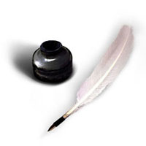
MAY 8-10, 2015
Call for papers
The Conference will address topics from the following fields
English and American Literature(including Comparative Literary Studies), Cultural Studies, Linguistics,
Translation Studies in English,
Language Teaching, Gender Studies,
and Other Related Topics
Abstracts for proposed papers (maximum 250 words) should be submitted to:
mustafacanli@karabuk.edu.tr
Please include your name, affiliation, email address and a brief biography.

Add 5-6 keywords pertaining to your topic.
The deadline for proposals is:
1 March 2015
The authors of accepted papers will be notified through email by 18 March 2015
The official language of the conference is English and the registration fee is
75 TL for regular participants and 50 TL for students.
Please check our website for details:
iwes.karabuk.edu.tr
For enquiries, please contact:
Assist. Prof. Dr. Özkan KIRMIZI: ozkankirmizi@gmail.com
Instr. Asım AYDIN asimaydin@karabuk.edu.tr
Res. Assist Mustafa CANLI mustafacanli@karabuk.edu.tr
Res. Assist. Hatice Esra MESCİOGLU: hmescioglu@karabuk.edu.tr

