CV

1. Surname: YILMAZ | 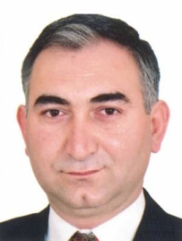
2. Name: KADİR
3. Date and Place of Birth: 19.01.1966 – Ankara
4. Marital Status: Married-2 Children

5. Educational Status:

Degree | Educational Institutions | Subject of Thesis | Graduate Date
Doctorate | Hacettepe University Institute of Social Sciences-Department of Sociology | Roles of National Media Managers for Generating of Programme Policy | 2004
Post Graduate | Kırıkkale University  Institute of Social Sciences- Department of Sociology | Effects of Television on Changing of Family Institution | 1996
Graduate | Middle East Technical University Department of Sociology |  | 1992

6. Language Skills: (1 – Very well ; 5 – Basic level)

Foreign Language | Reading | Speaking | Writing
English | 1 | 1 | 1

7. Computer Skills:

Knowledge of Microsoft Word / Excel / Access / Powerpoint

8. Total work experience: 24 years.
2012-…….. Karabuk University, Faculty of Letters, Department of Psychology – Assistant Professor.

2007-2012 Banking Regulation and Supervisiony Agency, Department of Education and Communication – Manager

2006-2007 Central Finance and Contract Unit (CFCU) – Contract and Project Manager

2003-2006 Ministry of National Education, Project Coordination Centre – Project Monitoring and Evaluating Manager, Finance Expert

1992- 2003 English Teacher

Telefon | 0505 565 71 05
E-mail | kadiryilmaz@karabuk.edu.tr

